Odoo Installation Report

# Part 1: Installation Process

## 1. Research and Document Hardware and Software Requirements

### ****Hardware Requirements:****

1. **Processor:**
   * Minimum: Dual-core processor
   * Recommended: Quad-core processor or higher for better performance.
2. **Memory (RAM):**
   * Minimum: 2 GB RAM
   * Recommended: 4 GB RAM or higher for better responsiveness, especially when handling multiple users or modules.
3. **Disk Space:**
   * Minimum: 10 GB of available disk space for Odoo installation.
   * Recommended: 20 GB or higher, especially if using a database with large amounts of data or multiple add-ons.
4. **Network:**
   * A stable internet connection is required for downloading packages and updates.

### ****Software Requirements:****

1. **Operating System:**
   * Ubuntu 22.04 (recommended)
   * Other Linux distributions, Windows, and macOS are supported but may require additional steps.
2. **Python:**
   * Minimum required version: Python 3.10 or higher.
   * Recommended: Python 3.11 to work with Odoo 17 seamlessly.
3. **PostgreSQL:**
   * Minimum required version: PostgreSQL 13 or higher.
   * PostgreSQL is the database system used by Odoo, so its installation and proper configuration are essential.
4. **Node.js and npm:**
   * Node.js: Version 14.x or higher.
   * npm (Node Package Manager) is required for managing frontend dependencies.
5. **Libraries and Dependencies:**
   * Python libraries such as pip, wheel, setup tools, and others specific to Odoo( automatically installed during the process).
   * **Additional system dependencies** may include:
     + libxml2-dev
     + libxslt1-dev
     + libevent-dev
     + libsass-dev
     + libldap2-dev
     + libjpeg-dev
     + libpq-dev
     + libpng-dev
     + python-dev
6. **Git:**
   * Required for downloading and managing Odoo source code from the repository.
   * Git version 2.x or higher.
7. **Web Server:**
   * Nginx or Apache (optional, for production environments where Odoo is exposed to the web).
8. **Browsers:**
   * Any modern web browser such as Google Chrome, Mozilla Firefox, or Microsoft Edge for accessing the Odoo web interface.

## 2. Install Git

**Command:** sudo apt install git  
Verify Installation: After installing, verify by running:

**git --version**

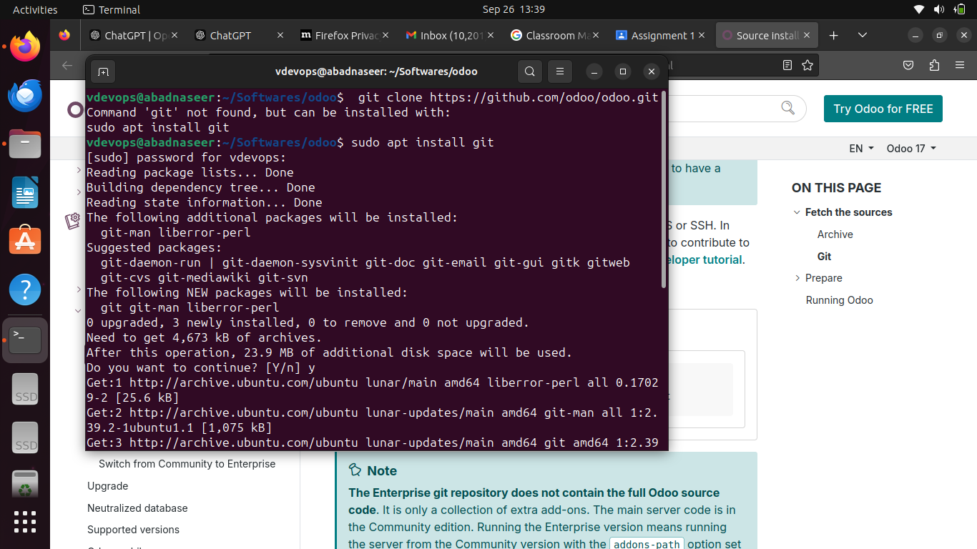

## 3. Clone Odoo Enterprise Code from GitHub

Task: Normally, I would clone the repository using:

**git clone** [**https://github.com/odoo/odoo.git**](https://github.com/odoo/odoo.git)

**Issue Encountered:** Due to GitHub security restrictions, the terminal did not allow me to clone the repository using Git. This issue typically arises due to credential restrictions (token-based authentication required).  
**Workaround:** Downloaded Odoo 17 source code via browser from GitHub directly. You manually searched for the Odoo repository, browsed the available versions, and selected **Odoo 17**.

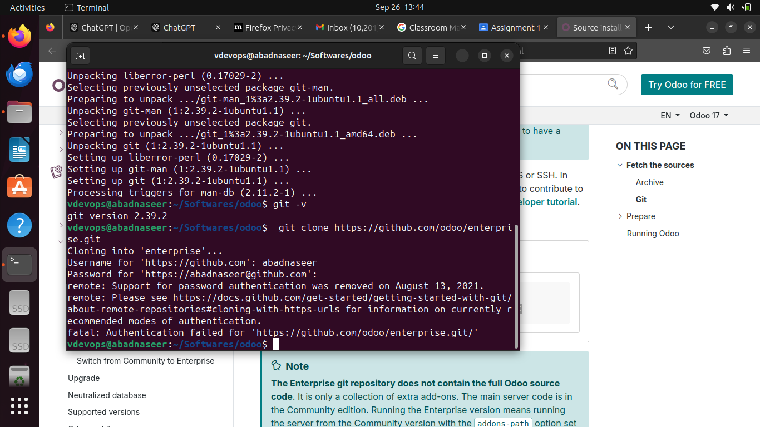

After I search for the odoo on google.com and found source code on github, I downloaded it.

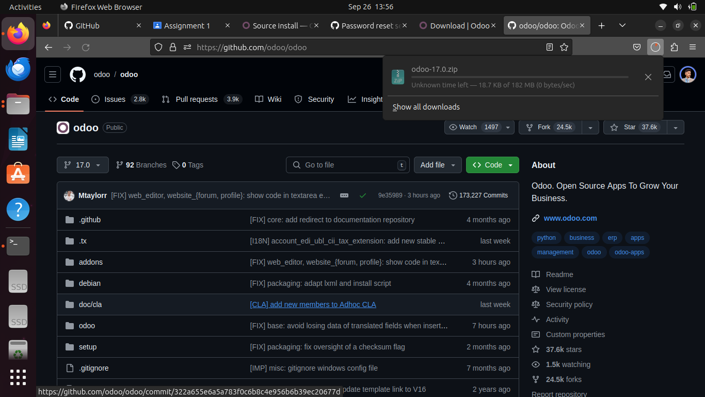

## 4. Python Version Check

Command: python3 --version  
Odoo 17 requires Python version 3.10 or above. I verified the Python version on your system and found it to be 3.11.

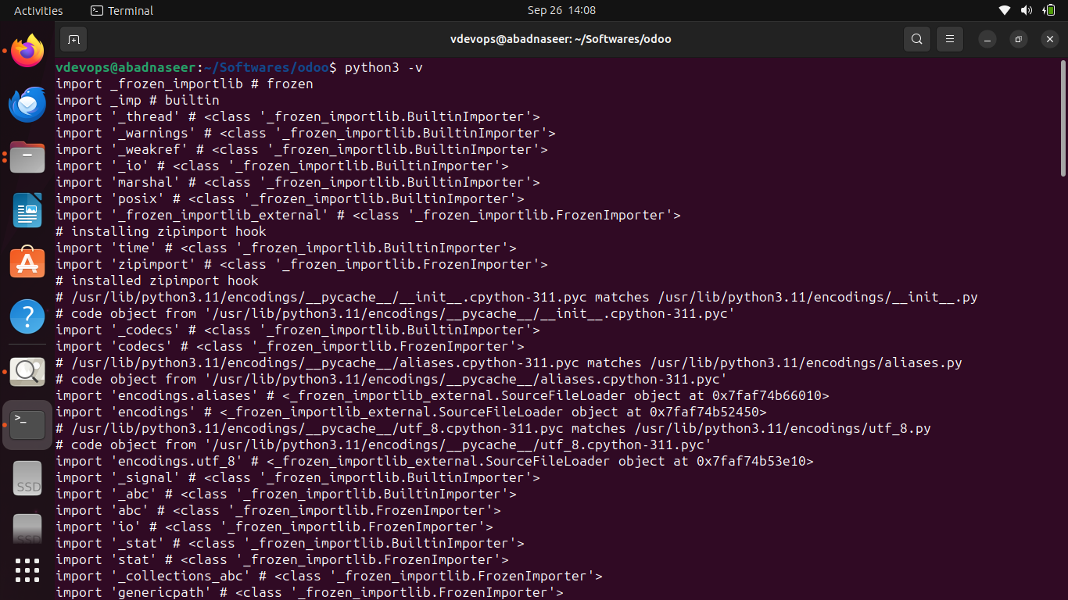

## 5. Verify and Install Pip

Command:

**pip3 --version**  
In my case, Pip was not installed, so I installed it using:

**sudo apt install python3-pip**

Verified the version before installation gave me information that pip was not installed. But, Verified the version after installation.

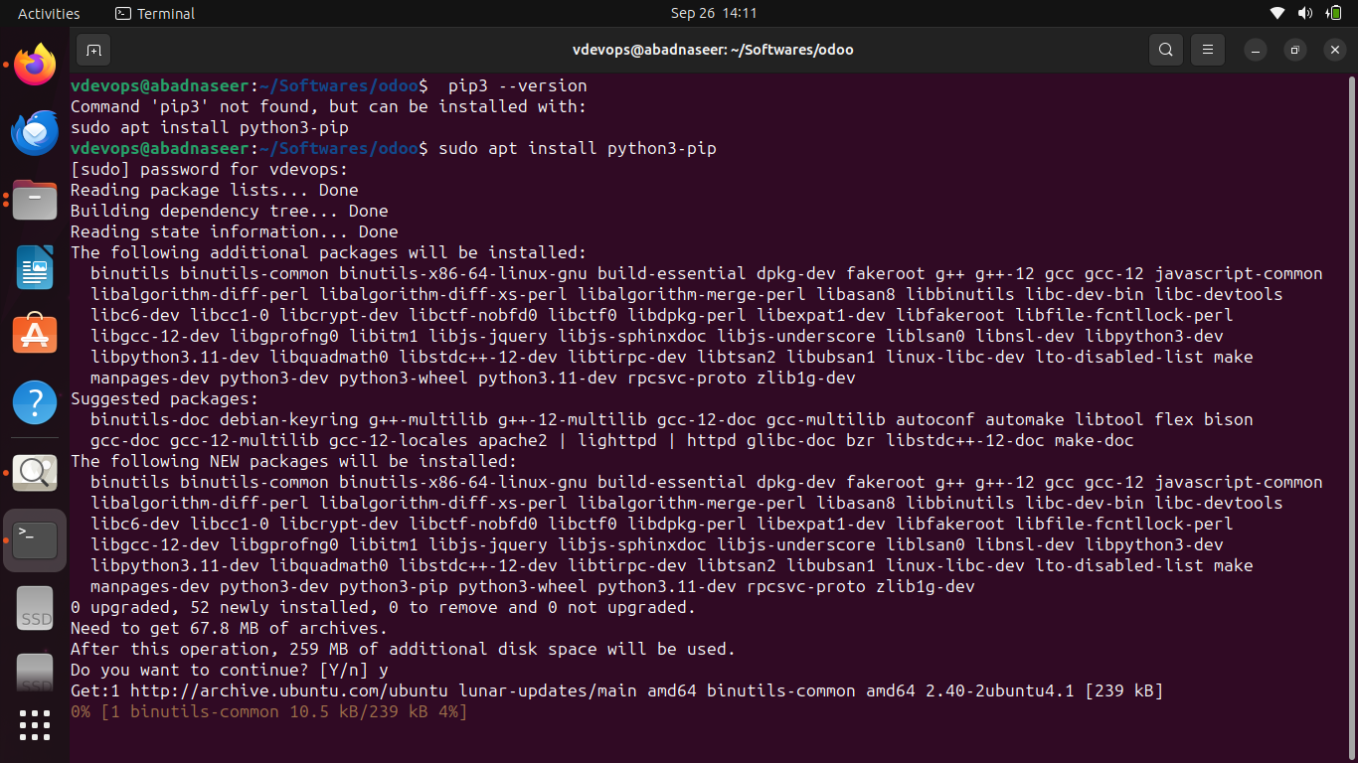

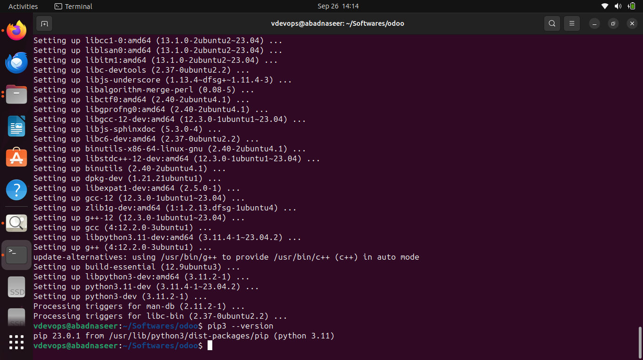

## 6. Install PostgreSQL

Command:

**sudo apt install postgresql postgresql-client**

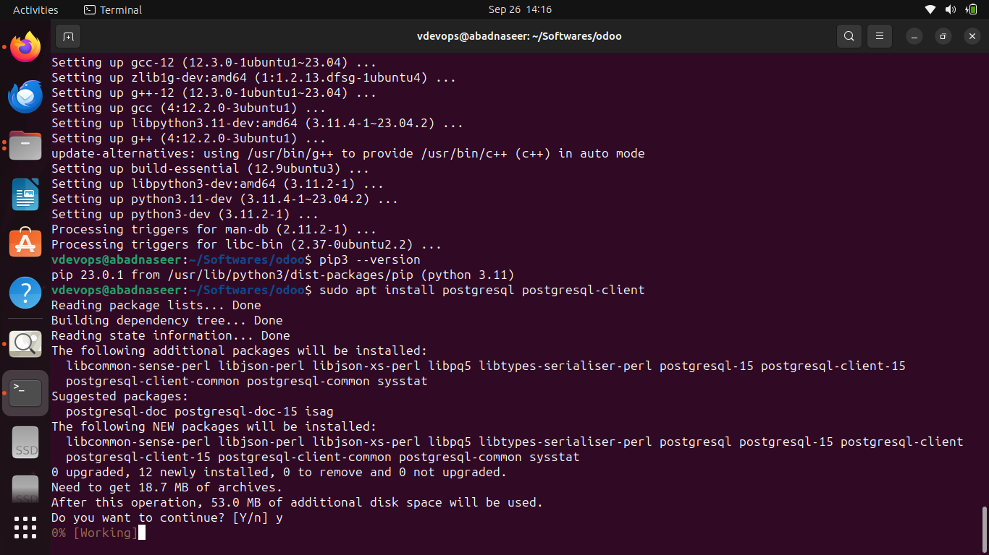**PostgreSQL Configuration:**

While creating a new PostgreSQL user, I encountered a permission issue related to accessing the home directory. After troubleshooting, I removed the existing postgres user and created a new postgres role with superuser privileges for managing databases in Odoo.

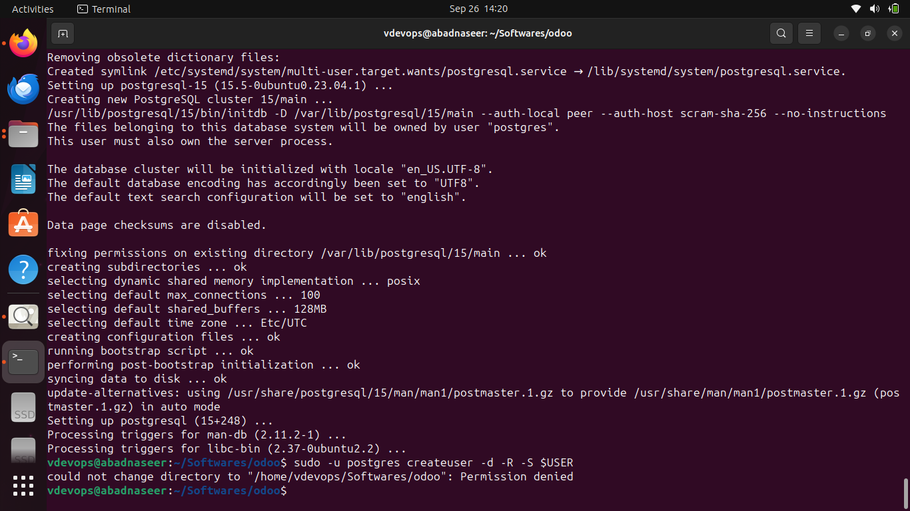

Command to create a user and role:  
**sudo -u postgres psql**

Command to check the user list under the system user ( postgres).

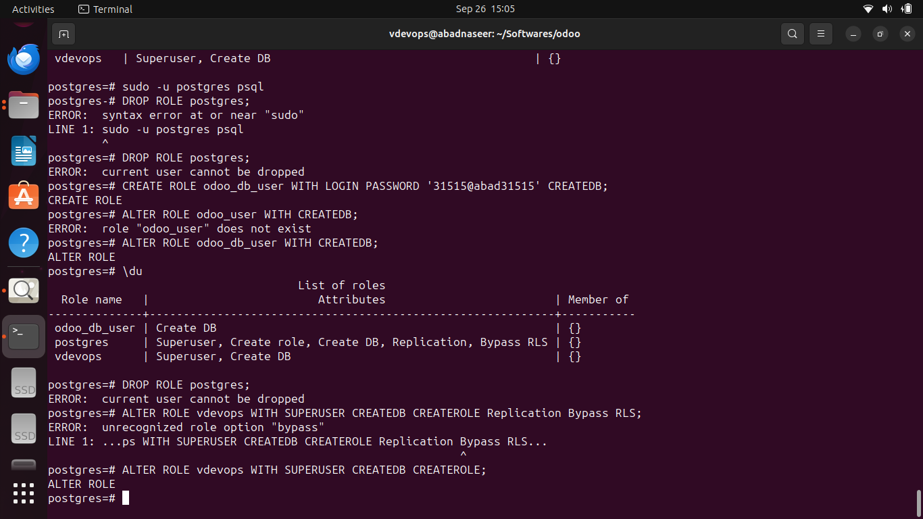

Here I have to delete “vdevops” user, but I was trying to remove postgres because I got confused. I learnt that postgres should be kept as system ( DBMS) user for odoo ( with all permissions related to managing database creation roles, assigning db to users).

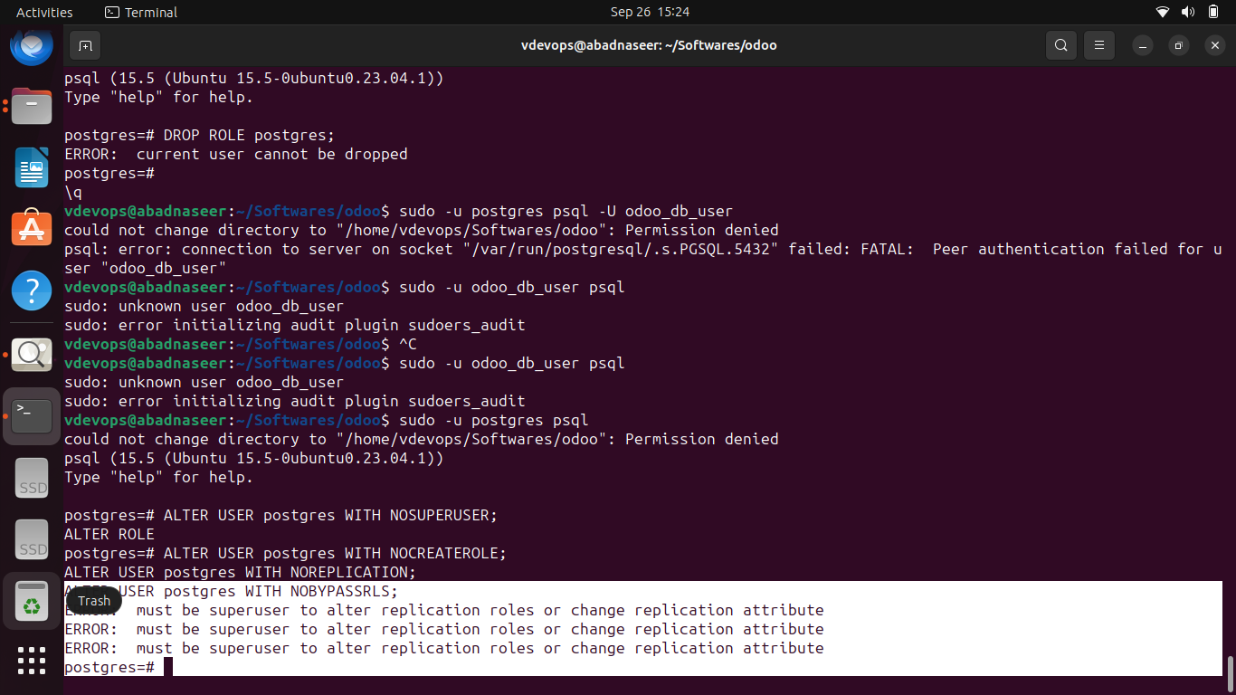

## 7. Install Odoo Dependencies

To install Odoo dependencies, I navigated to the Odoo community path and ran the following script:  
**sudo ./setup/debinstall.sh**

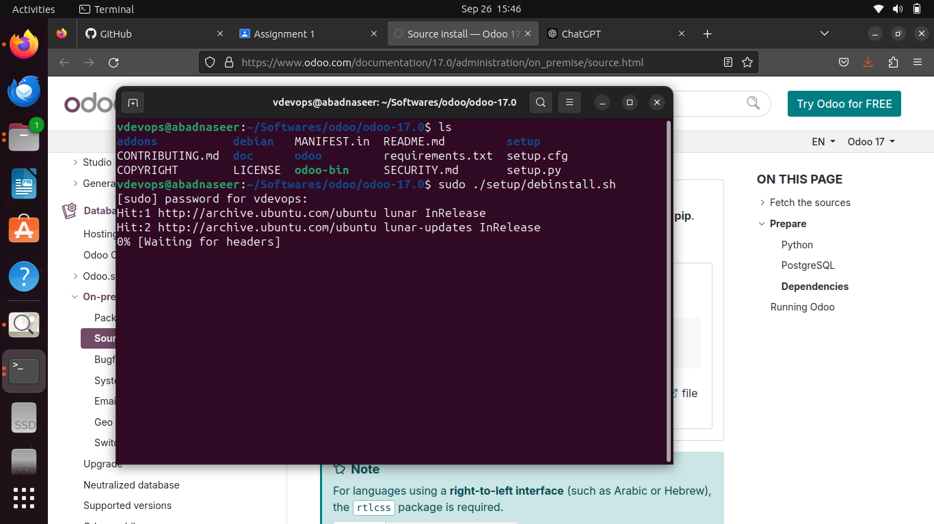

## 8. Running Odoo

**Command:**

**python3 odoo-bin --addons-path=addons -d mydb --db_user=odoo_user –db_password=<your-password>**

I initially encountered an error when switching back to PostgreSQL. To resolve this, I changed the PostgreSQL authentication method in the pg_hba.conf file, reset the user password, and reverted the file.

## 9. Accessing Odoo on the Browser

After completing the installation, I accessed Odoo by navigating to:

**http://localhost:8069**

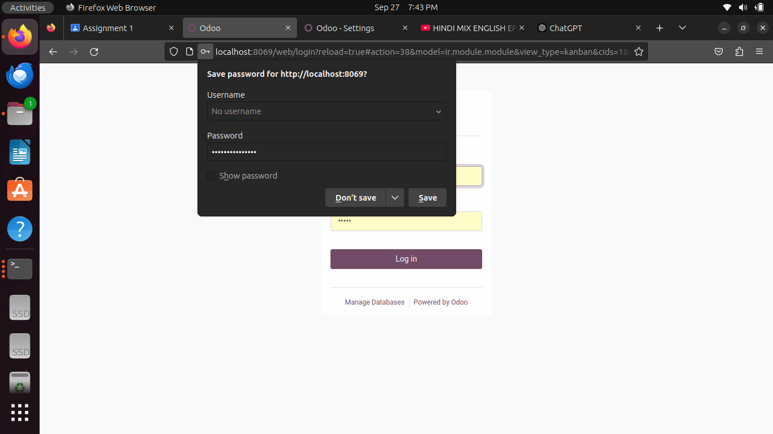

# Part 2: Initial Configuration of Odoo

## 1. Access Odoo Web Interface

After successfully accessing Odoo, I logged in using the default credentials.



## 2. Change Default Password and Create a New Admin User

I changed the default password for security purposes and created a new admin user with full privileges.



## 3. Explore Odoo Dashboard

Explored the dashboard and modules such as Sales, Inventory, and Accounting.

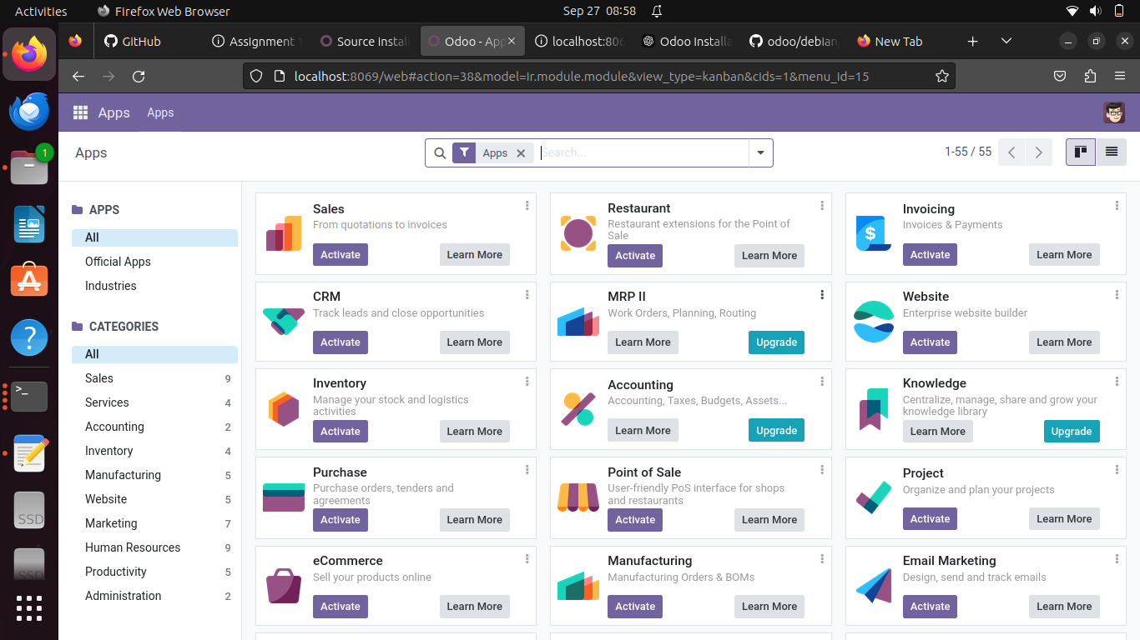

## 4. Configure Basic Settings

Configured essential settings, including:  
- Company information  
- Currency  
- Language  
- Timezone

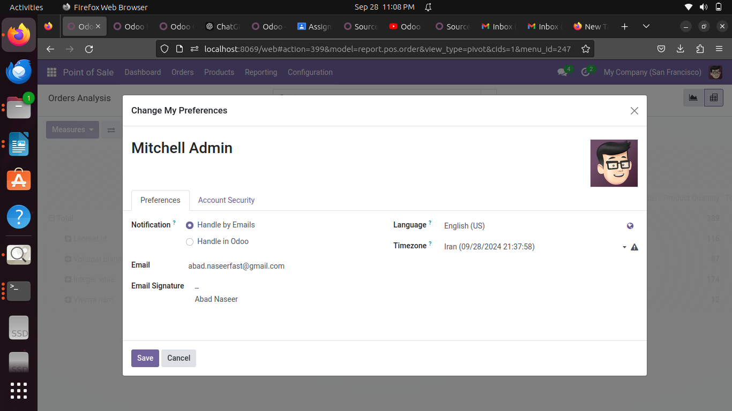

## 5. Install Additional Modules

Installed a few essential modules as per my requirement, such as Point of sale, Invoicing, and Inventory Management.

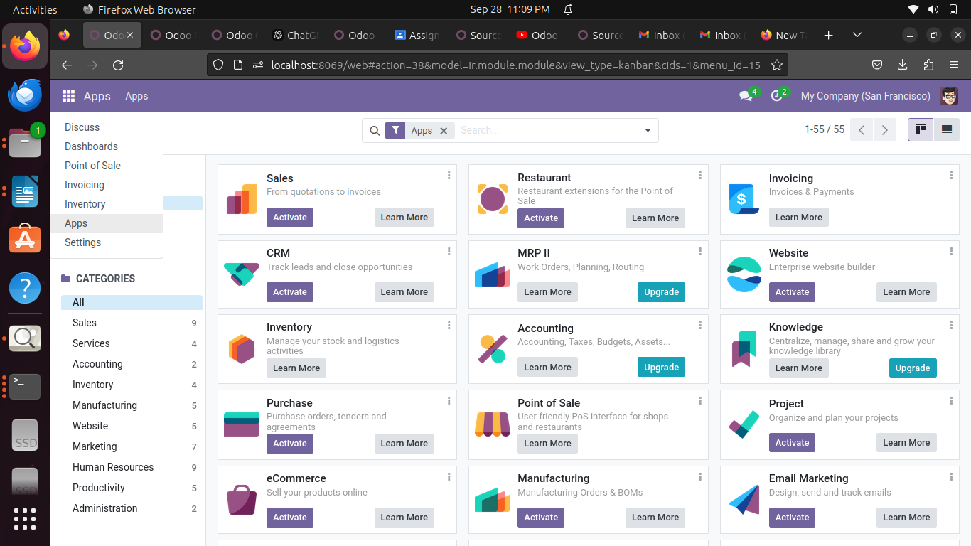

# Part 3: Customization Documentation

# POS Module:

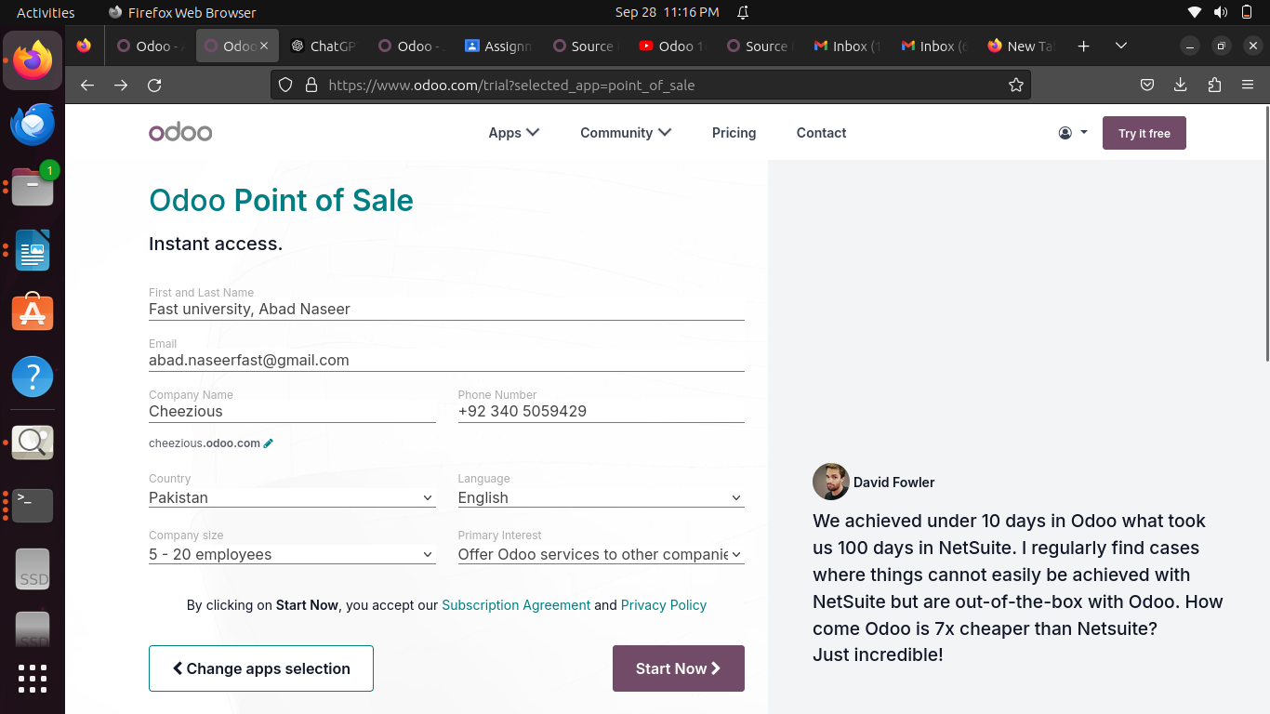

# 

# 

# 

# 

# Invoicing Module:

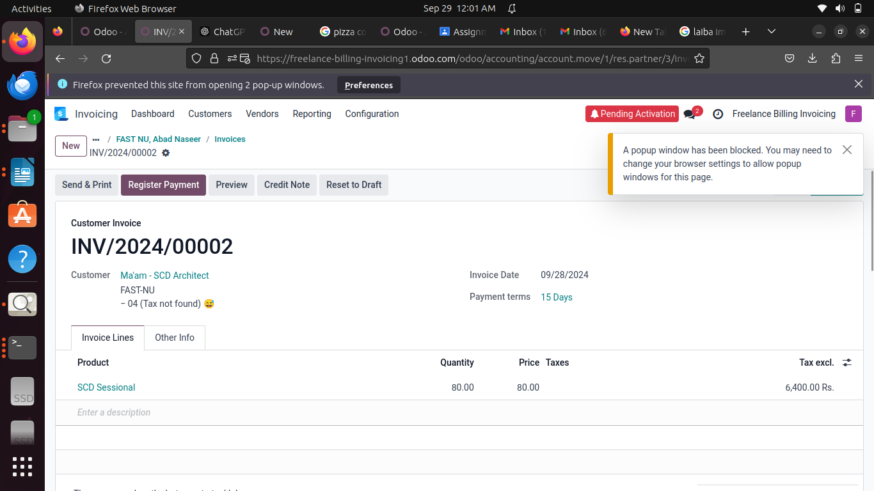**Point Of Sale:**

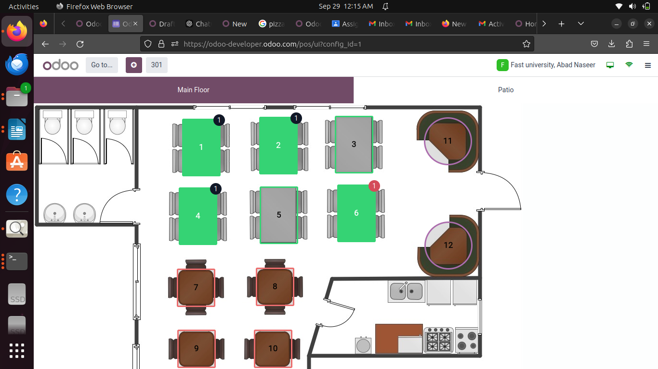

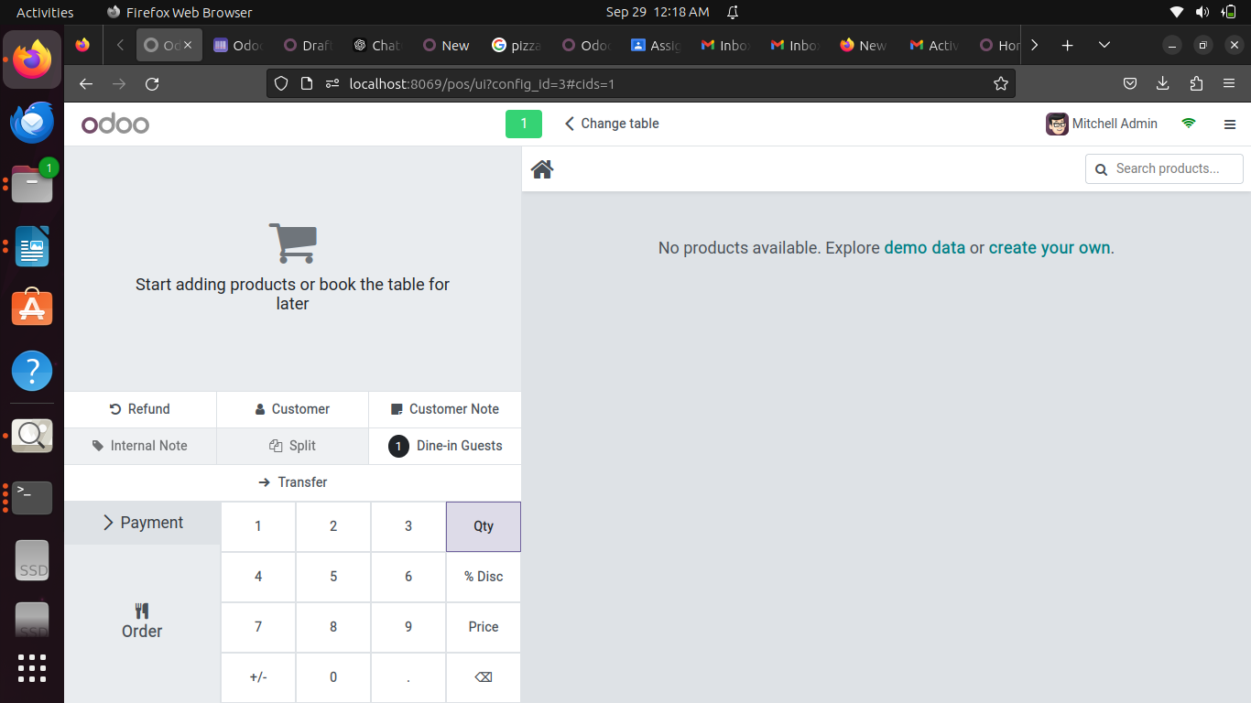

# Deliverables

1. Installation Documentation: A comprehensive guide documenting the installation steps, issues encountered, and how you resolved them.  
2. Configuration Report: A summary of the configuration steps, including the addition of admin users and the exploration of essential features in Odoo.  
3. Customization Documentation: Detailing any future customization efforts in Odoo modules.

# Evaluation Criteria

1. Accuracy of Installation: Odoo was successfully installed following the steps described.  
2. Completeness of Configuration: Basic settings were configured, and essential modules were explored.  
3. Creativity in Customization: No customizations were made yet.  
4. Documentation Clarity: The report is well-organized with clear instructions, explanations, and screenshots for each step.